**Hack The Box**



Steganography Challenge

Senseless Behaviour

Medium – 50 pts

sh3llf1sh

First as always we have to download a zip file which can be unlocked with password “hackthebox”, after we extract the zipped folder, we found the folder contain one audio file called “meow.wav”



Then I used tool called stegbrute to bruteforce passphrase used to encode the audio file, but at the first time I thought I need audacity to see the inside of that audio file. Okay, lets get to the next step, we need to run the “StegBrute” with this command “python3 stegbrute.py –image meow.wav –output hasil.txt –wordlist rockyou.txt” then we can found the passphrase is “skittles”

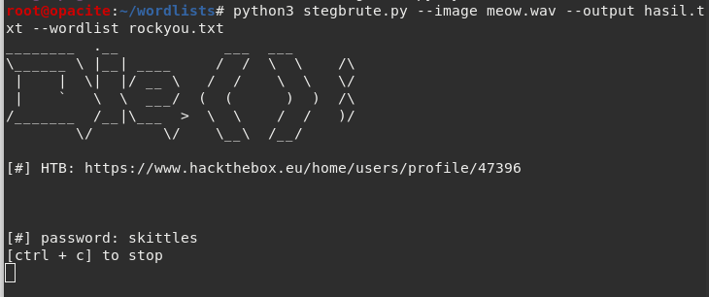

After that, we could use the steghide tool to extract what’s inside the audio file, as we can see the data inside the audio file is somehow like a random string

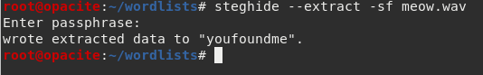

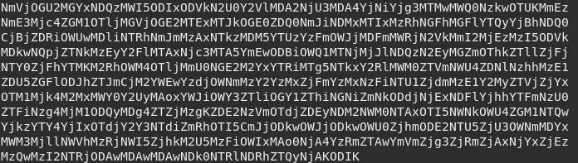

After examine what is the string type, I conclude that is a base64 encode, so after I tried to decode the string with **base64**, I got another random string like hex, then I use hex decoder from **CyberChef**, and got something interesting.



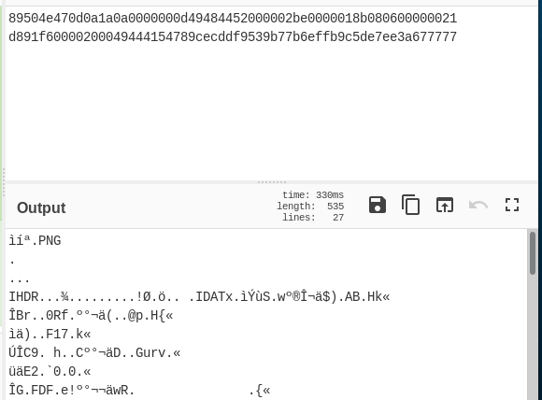

So the second random string is a PNG file, then we can conclude the file from audio file is an image with **png extension**. Using this command we could use hexdump to make a png file from that txt file.



Now we have the extension for that file, and we could see whats inside the file, and it is a meme picture

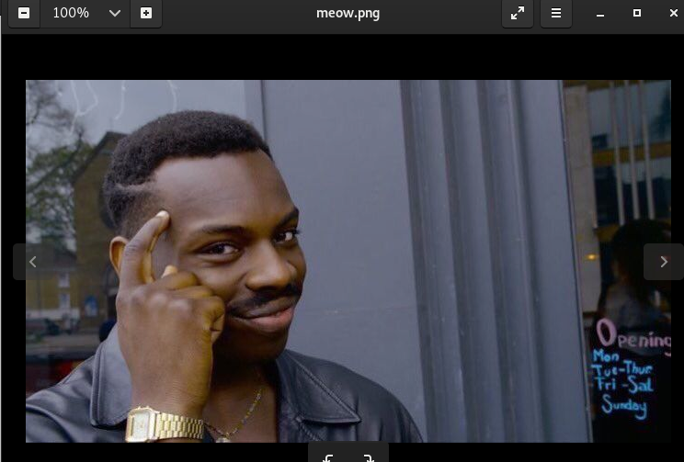

And I thought the flag hidden in metadata, but I was wrong, so I tried stegsolver to see maybe its behind the picture, then I found the dot character like a **Braille**

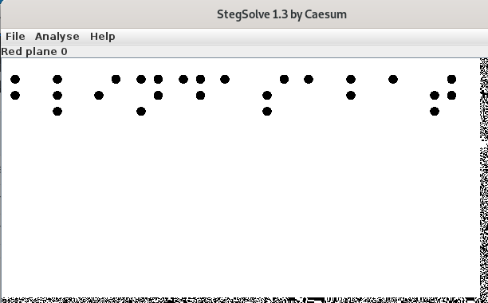

Using this web <https://www.pharmabraille.com/pharmaceutical-braille/the-braille-alphabet/> as a reference, I decrypt the **Braille**, the string is “**blindasabat**”, so append with HTB format, we got the full flag

**HTB{blindasabat}**